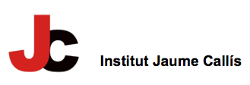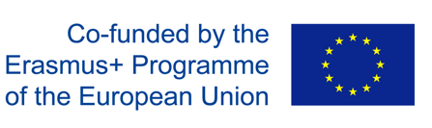

PROJECTE ERASMUS + KA101: “EEF: Envisioning our Education of the Future”
2019-1-ES01-KA101-060426

ANALYSIS OF THE RESULTS OF THE EVALUATION ON :
RESULTS, OBJECTIVES, IMPACT AND DISSEMINATION AFTER YEAR 1

Taking into account that the project was interrupted on 13 March 2020 with the closing down of schools in Spain, and that all mobilities planned till August 2020 had to be cancelled, and moreover, one of the participating teachers is no longer in our school, the evaluation survey has been answered by 11 teachers, and the questions in section A and C have only been answered teachers who took part in the job-shadowing period in Rome and the training course in Malta.

More than a half of the participating teachers in the project (54.5%) have more than a 20-year-teaching experience and teach different subject areas (Maths, Art, Social Science, English, French and Economy), most of them interested in improving their abilities in CLIL methodology.

Regarding the 3 main objectives of the project:
- Update teaching-learning methods;
- Widen the international scope of our school
- Improve key competences of teachers and students;

We can see that in section A, all teachers have rated the questions 3-5 on a scale of 0-5, which means that we are on the right track in achieving objective A. The same for objective B regarding the internationalization of our school.
In section C, we can see that the competences which have been improved by teachers are the linguistic competence, the intercultural competence and competences in the different methodologies.

Section D deals with impact, and again we see that most teachers rate the questions 3-5, although we have 1-3 teachers who have rated the training on ICT and new methodologies, , the transferability of the competences achieved and the creation of an international network with the hosting schools a bit low (2 in a scale of 0-5), which means that these three aspects need to be revised.

Section E deals with dissemination. This aspect really needs to be revised and improved; how to get to more people both within the school (co-teachers, families, students) and to a wider audience. Many suggestions have come up such as:
- organize workshops, training courses and speeches
- promote the school Instagram account
- sharing resources with other teachers
- presenting the project in Conferences, training courses…

Vic, 3 September 2020

